### UNIVERSITY ADMISSION CARE BD

**BY**

**Md Abir Hassan**

**ID: 181-15-1887**

**Md Kawser Ahamed**

**ID: 181-15-1722**

**AND**

**Mst. Tania Sultana Khanam**

**ID: 181-15-1945**

This Report Presented in Partial Fulfillment of the Requirements for the Degree of Bachelor of Science in Computer Science and Engineering

Supervised By

### Amit Chakraborty Chhoton

Lecturer

Department of Computer Science & Engineering

Daffodil International University

Co-Supervised By

### Saima Afrin

Lecturer

Department of Computer Science & Engineering

Daffodil International University



**DAFFODIL INTERNATIONAL UNIVERSITY DHAKA, BANGLADESH**

**17 JANUARY 2022**

# APPROVAL

This Project titled “**University Admission Care BD**”, submitted by Md Abir Hassan**,** Md Kawser Ahamed, and Mst. Tania Sultana Khanam to the Department of Computer Science and Engineering, Daffodil International University, has been accepted as satisfactory for the partial fulfillment of the requirements for the degree of B.Sc. in Computer Science and Engineering and approved as to its style and contents. The presentation has been held on 17 January, 2022.

**Board of Examiners**

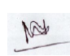

**____________________________**

**Dr. Md. Ismail Jabiullah Internal Examiner**

**Professor**

Department of Computer Science and Engineering

Faculty of Science & Information Technology

Daffodil International University



**___________________________**

**Narayan Ranjan Chakraborty Internal Examiner**

**Assistant Professor**

Department of Computer Science and Engineering

Faculty of Science & Information Technology

Daffodil International University



**____________________________**

**Dr. Mohammad Shorif Uddin External Examiner**

**Professor**

Department of Computer Science and Engineering

Jahangirnagar University

# 

# DECLARATION

We hereby declare that, this project has been done by us under the supervision of **Amit**

**Chakraborty Chhoton, Lecturer, Department of CSE Daffodil International**

**University**. We also declare that neither this project nor any part of this project has been submitted elsewhere for award of any degree or diploma.

**Supervised by:**



**Amit Chakraborty Chhoton**

Lecturer

Department of Computer Science & Engineering

Daffodil International University

**Co-Supervised by:**



**Saima Afrin**

Lecturer

Department of Computer Science & Engineering

Daffodil International University

**Submitted by:**



**Md Abir Hassan**

ID: 181-15-1887

Department of Computer Science & Engineering

Daffodil International University

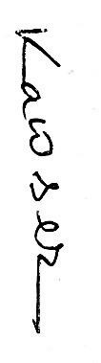

**Md. Kawser Ahamed**

ID: 181-15-1722

Department of Computer Science & Engineering

Daffodil International University

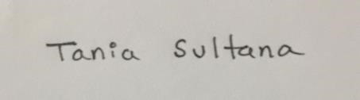

**Mst. Tania Sultana Khanam**

ID: 181-15-1945

Department of Computer Science & Engineering

Daffodil International University

# ACKNOWLEDGEMENT

First we express our heartiest thanks and gratefulness to almighty God for His divine blessing makes us possible to complete the final year project successfully.

We really grateful and wish our profound our indebtedness to Amit Chakraborty Chhoton, Lecturer, Department of CSE Daffodil International University, Dhaka. Deep Knowledge & keen1 interest of our supervisor in the field of “Field name” to carry out this project. His endless patience ,scholarly guidance ,continual encouragement , constant and energetic supervision, constructive criticism , valuable advice ,reading many inferior draft and correcting them at all stage have made it possible to complete this project.

We would like to express our heartiest gratitude to Amit Chakraborty Chhoton, Saima Afrin, and Professor Dr. Touhid Bhuiyan, Head, Department of CSE, for his kind help to finish our project and also to other faculty member and the staff of CSE department of Daffodil International University.

We would like to thank our entire course mate in Daffodil International University, who took part in this discuss while completing the course work.

Finally, we must acknowledge with due respect the constant support and patients of our parents.

# ABSTRACT

Our University Admission Care Service provides all aspects of the University Admission Test. From here we are students. We will guide the student perfectly. And the value goal of this project is that students will be able to prepare in a very short time. That is why we have a learning zone. From where students can take thematic preparation like themselves. They have a quiz system through online quiz system. After giving the quiz, they will know the marks and their ranking. For this project, we conducted a survey, where we are analyses the results and found that 70 percent of the candidates in the country are not aware of the admission test.

In this project, we have selected the agile model as the software model. Because the agile model works in contrast to the user. Most of the IT companies in the country are currently using agile models. We can say that we are committed to providing his services.

#### Table of Contents

**APPROVAL** II

**DECLARATION** IV

**ACKNOWLEDGEMENT** VI

**ABSTRACT** VII

**CHAPTER 1** 1

**1.1 Introduction** 1

**1.2 Motivation** 1

**1.3 Objectives** 1

**1.4 Expected Outcome** 2

**1.5 Report layout** 3

**CHAPTER 2** 4

**2.1 Introduction** 4

**2.2 Background Study** 4

**2.3 Related work** 5

**2.4 Scope of problem** 7

**2.5 Challenges** 7

**CHAPTER 3** 9

**3.1 Business Process Model** 9

**3.2 Requirement’s analysis** 9

**3.3 Analyzing & Design** 10

**3.4 Testing & coding** 10

**3.5 Maintains** 10

**3.6 Flow Diagram** 11

**3.7 Use case Diagram And Description** 11

**3.8 Logical Data Model** 12

**3.9 E.R Diagram** 14

**3.10 Design Requirements** 15

**CHAPTER 4** 16

**4.1 Front End** 16

**4.2 HTML5** 16

**4.3 CSS** 17

**4.4 Bootstrap** 18

**4.5 XAMPP** 19

**4.6 PHP** 20

**CHAPTER 5** 22

**5.1 Implementation of Dataset** 22

**5.2 Testing** 28

**5.3 Result** 29

**5.4 Output** 29

**CHAPTER 6** 31

**6.1** **CONCLUSION & DISCUSSION**: 32

**6.2** **FUTURE SCOPE:** 32

**References** 33

**LIST OF FIGURES**

|  |  |
| --- | --- |
| **Figure** | **Page number** |
| **Admission war** | **6** |
| **Result bd** | **6** |
| **Agile model** | **9** |
| **Follow chart** | **10** |
| **Usecase diagram** | **11** |
| **Data flow model** | **12** |
| **Er** | **13** |
| **Html code** | **14** |
| **Css code** | **17** |
| **bootstrap** | **18** |
| **xampp** | **19** |
| **Php code** | **20** |
| **Create database** | **22** |
| **Database list** | **23** |
| **User database** | **24** |
| **Question database** | **25** |
| **Frontend output** | **29** |
| **Account login** | **30** |
| **signup** | **31** |

**LIST OF TABLES**

|  |  |
| --- | --- |
| **Name of table** | **page** |
| **Report layout** | **3** |
| **Comparative study** | **8** |
| **Design requirement** | **15** |
| **Testing** | **28** |

# CHAPTER 1

## INTRODUCTION

#### 1.1 Introduction

Education is the backbone of the nation. Education in our country can be divided into 3 parts. Namely primary, secondary, third. Primary level (1-5), secondary (8-10), and third (university). University is the highest educational institution in our country. Every student dreams of going to a university. Today, university admission tests have become a regular battleground. Students can fulfill their dreams in a collaborative and good way. A student of our website, they will tell me varsity type 1st, what kind of varsity, what kind of questions and how to prepare. One of the features of our website is the learning zone where students can read as they like and from here they can remember to read various small tips and tricks. We have an online quiz system where students can log in and take quizzes, how many answers are correct or not, and will be ranked according to their number. We have a Google Map support system for test sites so that students can easily reach their destination.

## 1.2 Motivation

We have done a survey and found that 70% of the students in our country do not know about the admission test. The remaining 30% of the students can find out through their elder brothers or others through the coaching center. We want to be able to do this for those who don't know, so we can think of ourselves as successful, so this project has been planned.

## 1.3 Objectives

1. Our main goal is to make a website where students can get proper guidelines for university admission.
2. Students can learn from our website for admission preparation.
3. Students get all the information about all the public universities in

Bangladesh. (Subject requirement, map)

1. Students can test their skills in the self-test zone. They can give quiz/model tests on their preferred subjects and see their study progress.
2. Students can get university subjects related to future planning and the future of the subject in the job sector.
3. Students can get to their preferred university by giving their results and studying medium.
4. Students will receive all admission notices and upcoming events on our website. viii. They can get their admission test results and upcoming events by SMS/ email.

ix. There will be a help desk, where students can get hostel/hall facilities at the time of admission test.

## 1.4 Expected Outcome

The expected outcome of this project is given below:

1. This will be an easy way to collect university information.
2. There will be proper guidelines and information about all public universities in Bangladesh.
3. Learning and self-testing will help students to be preferable for admission tests from home.
4. This website will be user-friendly.
5. All information will be given to the student by mail/SMS.

## 1.5 Report layout

|  |  |
| --- | --- |
| **Chapter number** | **Description** |
| 1. | Introduction, motivation, expected outcome |
| 2. | Background study, related work, comparative study, scope of problem, challenges. |
| 3. | Requirement’s collection, use case model, logical data model, business process model. |
| 4. | Application of project design |
| 5. | Implementation and testing |
| 6. | Conclusion and future scope. |

# CHAPTER 2

**BACKGROUND STUDY**

## 2.1 Introduction

Through our project, a student will be able to fulfill the biggest dream of his life while sitting at home. For him, he can take advantage only if he has internet and a smartphone. A student without wasting his precious time with us and our Web Based Project

“University Admission Care BD“ is giving us this opportunity. From there, she will have access to admissions notice updates, time schedules, and self-test quizzes for selfverification. Hopefully, with us, students will be able to easily fulfill their cherished dreams.

## 2.2 Background Study

The author of [1] developed an educational website along with an android app. They launching an android application. Their project gives any updated information. The facility of the project is the registration process, updated news, notification, job circular, university news, security, etc. So, anyone can log in to their website, get updated news, notification easily. Their android app is a stage to get every opportunity in a moment. But their website has not some facility just like, have not to give any study reference, no group discussion, no solution of any question, no mentor to give any suggestion. If the website gives study materials, model questions, and gives mentors then it is better for a student who does not have the ability admitted into a coaching canter.

The author of [2] has made a web-based project only for students who are interested admitted into a private university. This project is for a private university. In the year 2020 Bangladesh have 53 public universities and 103 private universities. The author worked for the first 65 private university information by the ranking system in Bangladesh. The main facility of their project is user admin interaction. They used a special database to store information. Here students can get details of all private universities. Any student can know about credit and tuition fees, a map view, find the most appropriate subject. The author gets the idea from a site in Germany named Daad. This website [Daad] works for foreign students. The private university admission office will also be benefitted from this website.They use HTML,CSS,javascript for front end design. For backend design, they use PHP and MYSQL. But their app does not have all the facilities for admission students. They do not include any public university admission procedure. They do not include any study references, no job circular. Their app is only for undergraduate students but not graduate and diploma students. If they add public university admission information and also add some study references for undergraduate students I think their site may be perfect enough. Because in 2021 Bangladesh has 53 public universities and 85 private universities.

The author of [3] said that the main aim of this report is to assess the comparative status of the under-graduate admission in the different faculties at the Bangladesh Agricultural University (BAU) . The author gives special attention to veterinary medical education based on options given by the applicants and admitted students. Here the author mainly focused on the DVM [Doctor of Veterinary Medicine] degree. East Pakistan Agricultural University [EPAU] is now Bangladesh Agricultural University [ BAU].In the faculty of veterinary science, there are eight faculties. And there are three degrees [D.V.M, Ph.D., M.S]. This faculty is now equipped with international standards and is ideal for higher teaching and research. This project helps students. To know the requirement of BAU, how many sits reserve for foreign and bd students. They also discussed the aim of a veteran. Here other faculty information is not given. Masters, Doctoral, diploma degrees will not discuss. Admission-related information is less discussed here. It is not made for all public and private universities. If the author discussed other faculty of this university then it would be helpful for all those students who are like this agricultural university.

## 2.3 Related work

There are 3 web sites in Bangladesh like our project[3],[4],[5]. I don't think one of their students will get a good guide line. Because their web site is not suitable for full admission test, their web sites do not update the data regularly. I think their site is cluttered. Their web site has cluttered admission test notices, circulars, PDF books, but it is a big responsibility to understand how a student can start from their site.

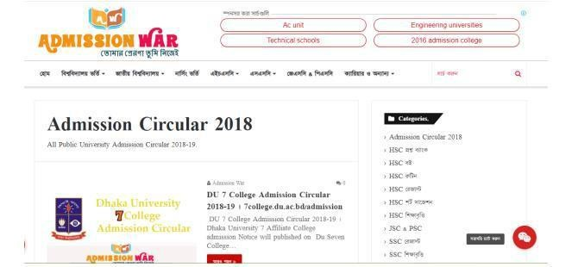

Figure: 2.1 admission war

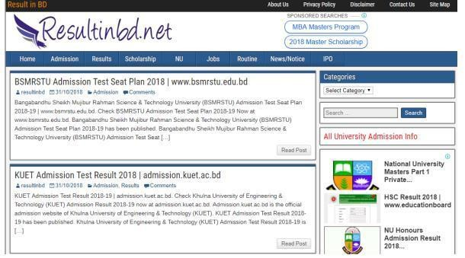

Figure: 2.2 Result bd

**2.4 COMPARATIVE TABLE :**

|  |  |  |  |  |  |
| --- | --- | --- | --- | --- | --- |
| **Case** | **University**  **Admission**  **Care BD** | **Admission War** | **Eduicon.Com** | **Admission Help Desk** | **10 Minute School** |
| Registration Login | Yes | No | No | Yes | Yes |
|  |  |  |  |  |  |
| Question Bank | Yes | Yes | No | No | No |
| Learning Zone | Yes | No | No | No | Yes |
| Online Quiz System | Yes | No | No | No | --- |
| Notices & Update News | Yes | Yes | Yes | Yes | Yes |
| Motivation | Yes | No | No | No | No |
| Subject  Review & Future | Yes | No | No | No | --- |
| Help Desk | Yes | No | No | No |  |

## 2.4 Scope of problem

* Not all areas may have internet service.
* Many may not have Internet-enabled devices.
* They cannot make efforts on online learning systems.
* Regular university update notices will be tough to give. • Sometimes it will be hard to reach them by SMS/email.

## 2.5 Challenges

* Authentic information.
* Latest information.
* User friendly.
* Data collection and Time maintenance
* System control management.
* Suitable learning zone.
* Database management.

# CHAPTER 3

**Requirements - collection & business process model.**

## 3.1 Business Process Model

There is a specific model for the development of all projects, this model develops the project, and the system management, for our University Admission Care BD project, we have chosen the Agile model, because we know that web development projects are organized in a few steps. As it happens, user feedback is very important for web development. Software development is done with this user feedback.

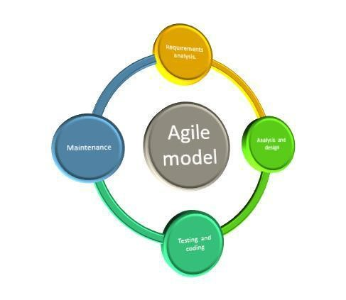

3.1 Figure: Agile model.

## 3.2 Requirement’s analysis

The first step of the agile model is the need analysis, for this analysis one has to plan the project here, and find the information accordingly, and create a pre-design by analysing that information. And to understand more from knowledge is to achieve.

## 3.3 Analyzing & Design

The job of the analysis and design steps is to design the innovation with a plan from requirements analysis. Here the design process is done in a very simple way for the user to use. Coding is done after design. A designer is hired for this job. All coding and design.

## 3.4 Testing & coding

The job of testing and coding is to control all types of logical testing of the project. For example, viewing projects, connecting to the database, then checking at different levels of admin editing and deleting. to the maintenance team.

## 3.5 Maintains

Below is a list of tasks that the maintenance panel does [11]:

1. They determine the project plan.
2. Error found in the project.
3. Budget.
4. Statistics and financial calculations.
5. Develop maintenance methods.
6. Complies with safety laws.
7. Manage equipment and stock.

## 3.6 Flow Diagram

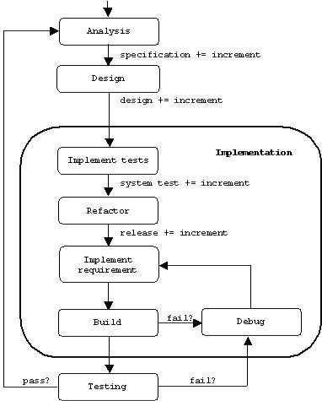

3.2 Figure of Agile model follow chart.

## 3.7 Use case Diagram And Description

Use case diagram This basically represents the user activity of a project. Through this the user gets a complete idea about the project and can learn about the usage. It carries the If the user goes to the 1st browser and searches by typing University Admission Care BD, our project website, there are many features of our project, for example: by going to the learning zone, the user will be able to study subject-based from here, then the student from here update notice option. If the user wants to give an online quiz, in that case, the user registers, he can take the exam and see his exam mark and his ranking. For admin, by logging in here, the admin can add questions and delete them. The student database can update the required data.

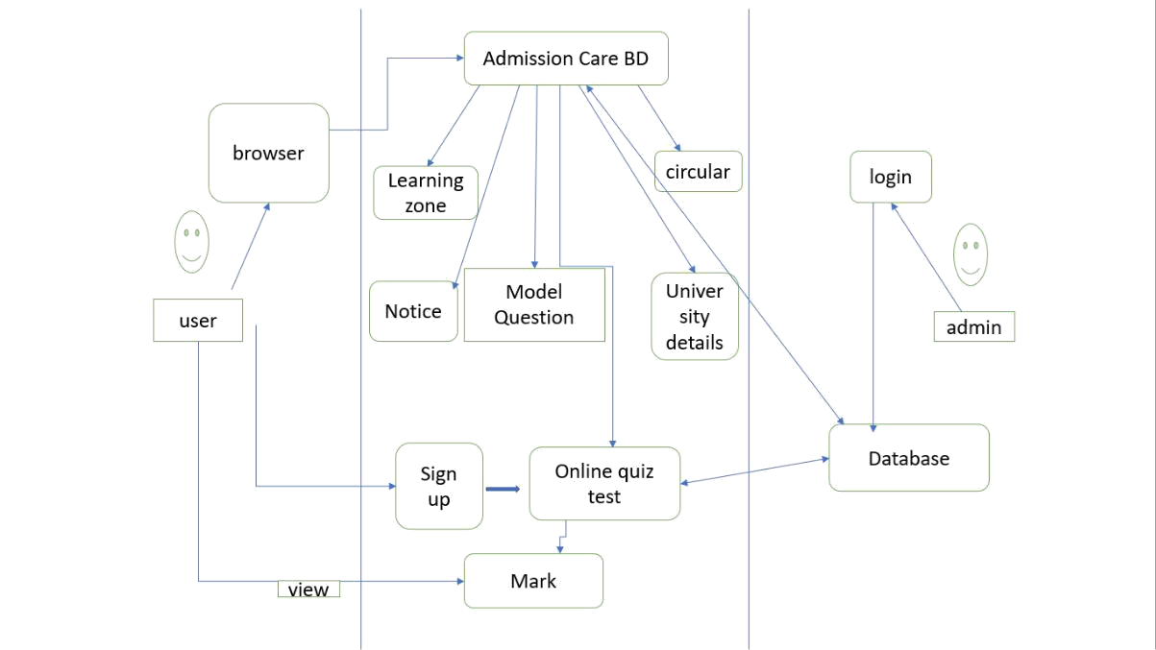

3.3 Figure: Use case Diagram

## 3.8 Logical Data Model

The logical data model shows how a model's data works directly. Through this, it is known how the admin and the user are involved in the project. Here the user can register and take the exam, through which the admin can update the database, and if necessary delete it.

Below is the data flow diagram:

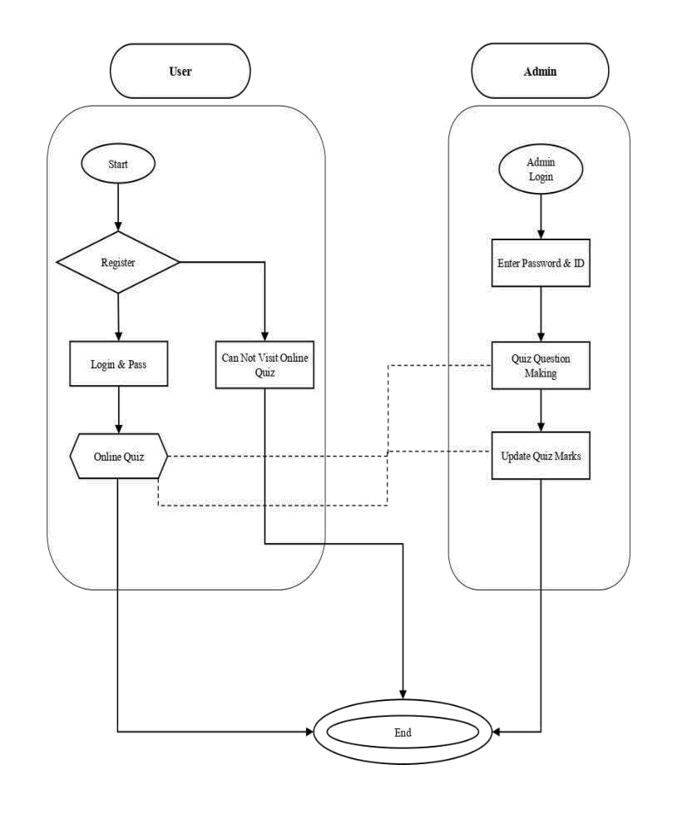

3.4 Figure: Logical Data Model Flow

## 3.9 E.R Diagram

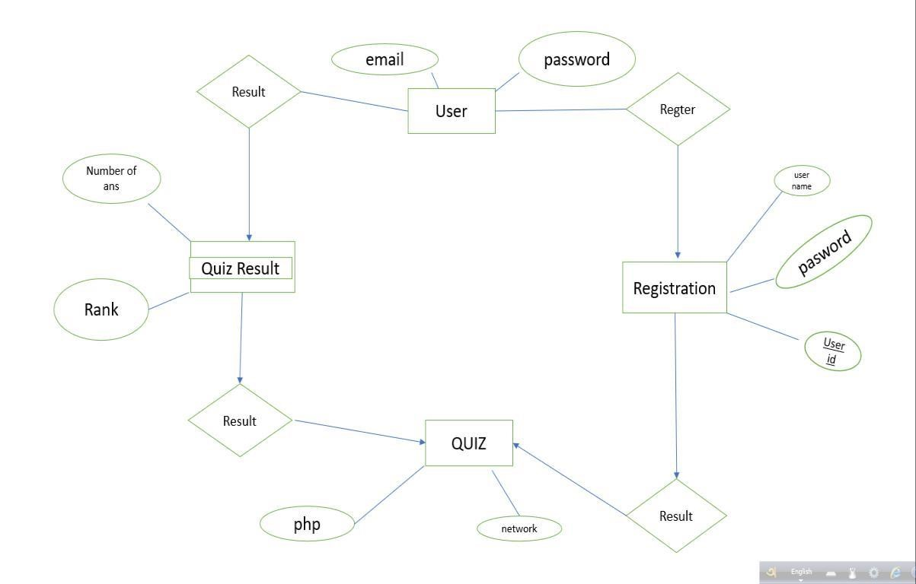

3.5 Figure: ER diagram

## 3.10 Design Requirements

Design requirements play an important role in the project. The design model makes the project usable. Because of this, the work of user admin becomes comparatively much easier.

|  |  |  |  |
| --- | --- | --- | --- |
| **SL NO** | **Parameter** | **Admin** | **User** |
| 01 | Registration | No | Yes |
| 02 | Log in page | Yes | Yes |
| 03 | Take action | Yes | No |
| 04 | Password change | Yes | Yes |
| 05 | View | Yes | Yes |
| 06 | Update info | Yes | No |
| 07 | Profile | Yes | Yes |
| 08 | Logout | Yes | Yes |
| 09 | User service | Yes | No |

# CHAPTER 4

**Application of project design**

## 4.1 Front End

The front end is part of the presentation layer in seven layers. Here is the view part of a website, with the help of which the work in front of the website can be seen. Often times the user can edit or not. Described:

## 4.2 HTML5

HTML5 stands for Hyper Text Markup Language and is the full form of HTML. HTML serves as the foundation for all websites. Without HTML, we wouldn't be able to organize text, add photographs, or videos to any internet pages. HTML is a good place to start if you want to learn how to make entertaining web pages. We use it to create the frontend of our websites using markup language. It's a cross between hypertext and markup languages. It's used to create electronic documents (known as pages) that may be viewed on the Internet. Each page contains a series of hyperlinks that go to other pages. Every web page we visit was made with the same HTML version. HTML5 was used on our website.

HTML5 is a new version of HTML.

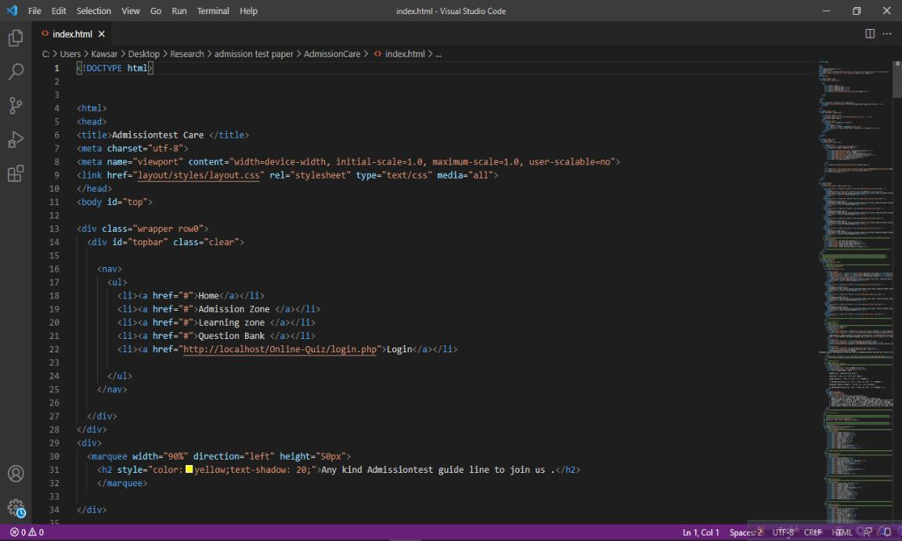

4.1 Figure: Html5 code

## 4.3 CSS

Cascading Style Sheets (CSS) is an acronym for Cascading Style Sheets[8]. The styles for web pages were defined using CSS. CSS allows us to control, among other things, text color, font style, paragraph spacing, column sizing, and layout designs. It is not dependant on HTML and can be used with any XML-based markup language. We employ CSS on our website for a variety of reasons, which are detailed below:

*Before CSS, every web page had to duplicate font, color, background style, element alignments, border, and size. This was a time-consuming procedure. CSS, on the other hand, fixed the issue.

*Because CSS style definitions are stored in external CSS files, changing only one file might affect the entire website.

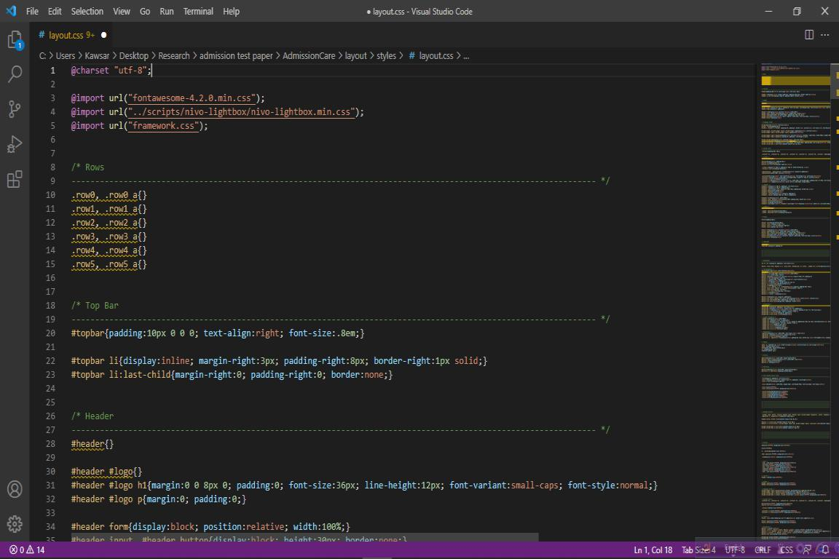

4.2 Figure : Css code

## 4.4 Bootstrap

Bootstrap is a framework for creating web pages that makes them easier and faster to create [9]. It provides design templates for typography, forms, buttons, tables, navigation, modals, photos, and more in HTML and CSS. JavaScript plugins can be used with them as well. For the reasons given below, we use bootstrap. The most popular framework for creating layouts is Bootstrap. The responsive CSS in Bootstrap adapts to mobile devices, tablets, and desktops. Bootstrap comes with mobile-first styles built in. Bootstrap is compatible with all modern browsers (Chrome and Firefox). Bootstrap has a large and inviting community. We can install Bootstrap and have a functional layout in less than an hour.

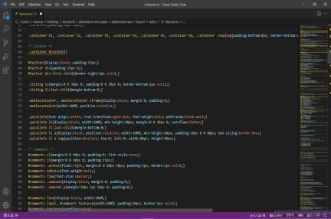

4.3 Figure : Bootstrap

## 4.5 XAMPP

XAMPP: XAMPP(X= cross-platform,A=Apache,M=Mysql,PP=PHP and Perl) is a free and open-source program.XAMPP allows localhost to test a website on PCs and laptops before publishing it to the main server. It offers a suitable environment for testing and evaluating the functionality of Apache, Perl, MySQL, and PHP-based projects on the host's system. Perl is a computer language for web development. PHP is a scripting language for the backend. The most popular MySQL database is MariaDB. We used XAMPP because of some reasons:

* Really simple for setting up and utilizing.
* Multi-platform application that operates on a number of platforms, including Linux and Windows. *Many additional vital modules are included, including phpMyAdmin, MediaWiki, WordPress.
* Comes in two sizes: regular (smaller) and full (bigger) (larger version).
* We may give a single command to start and terminate the entire webserver+database stack.

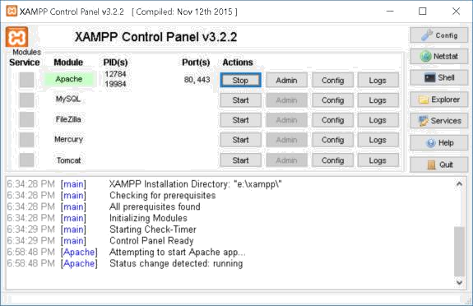

4.4 Figure : Xampp

## 4.6 PHP

PHP, which originally stood for Hypertext Pocessorrepr, is a server-side scripting language used during web development []. PHP code runs on the server, which is why it is referred to as a server-side scripting language. PHP code can be embedded in includes object parameters.and it was published in 2017.

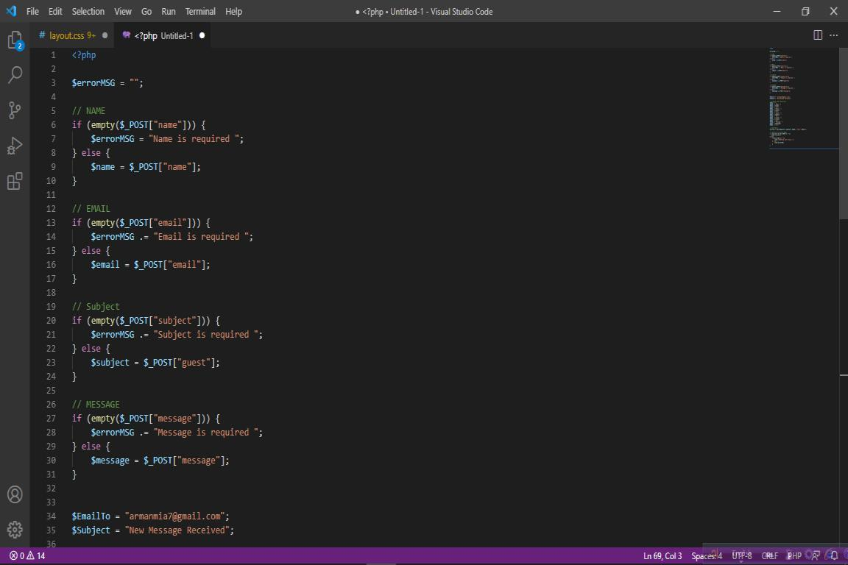

4.5 Figure : php code

# 

# CHAPTER 5

**IMPLEMENTATION AND TESTING**

## 5.1 Implementation of Dataset

Data is the most important thing. Data is used for all tasks. After preparing the previous year's questions for the preparation of the admission test, it is understood by looking at the questions what kind of questions will be. So saving data is very important. A lot of predictions can be made by doing a lot of analysis through data. A database management system can help you establish a more organized and efficient working environment. SQL, for example, is a database query language that makes it simple to access, change, and process data contained in databases.

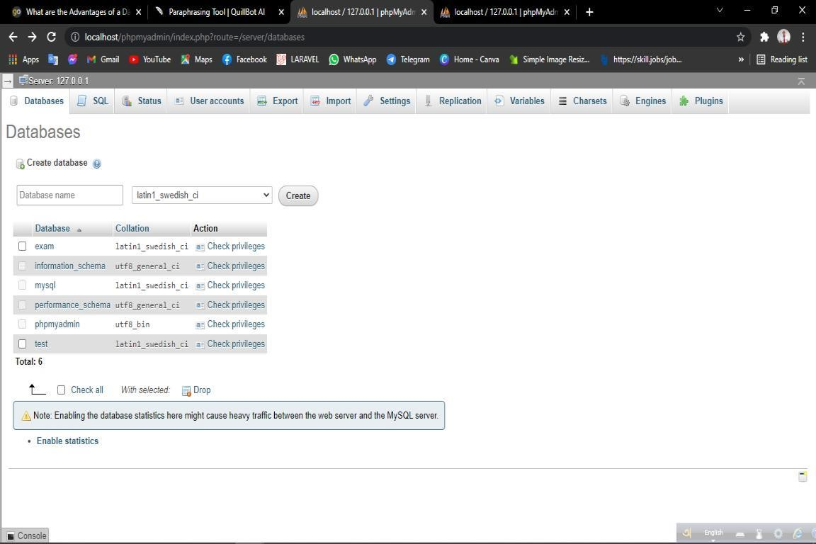

5.1 Figure: Create Database

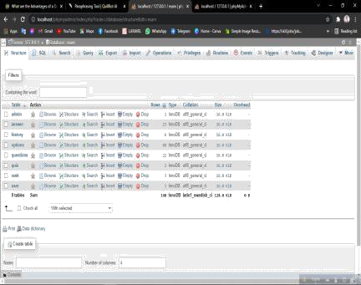

5.2 Figure Database list

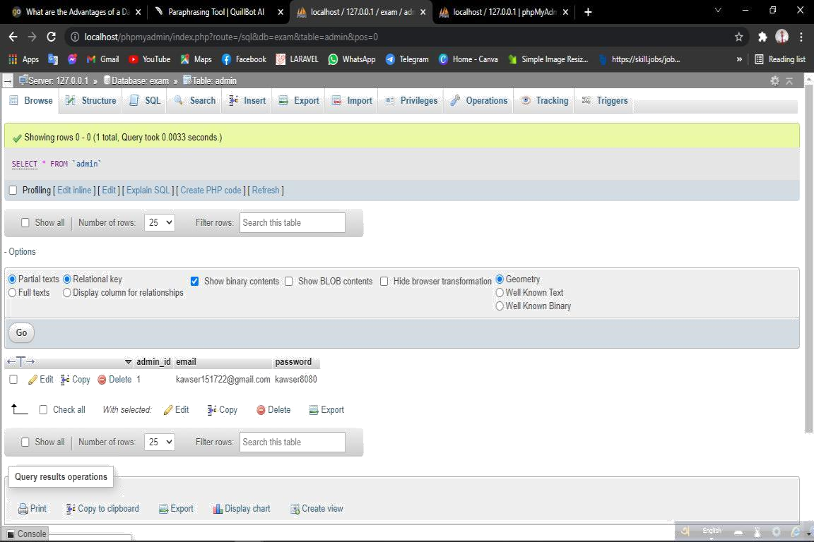

5.3 Figure : Admin database

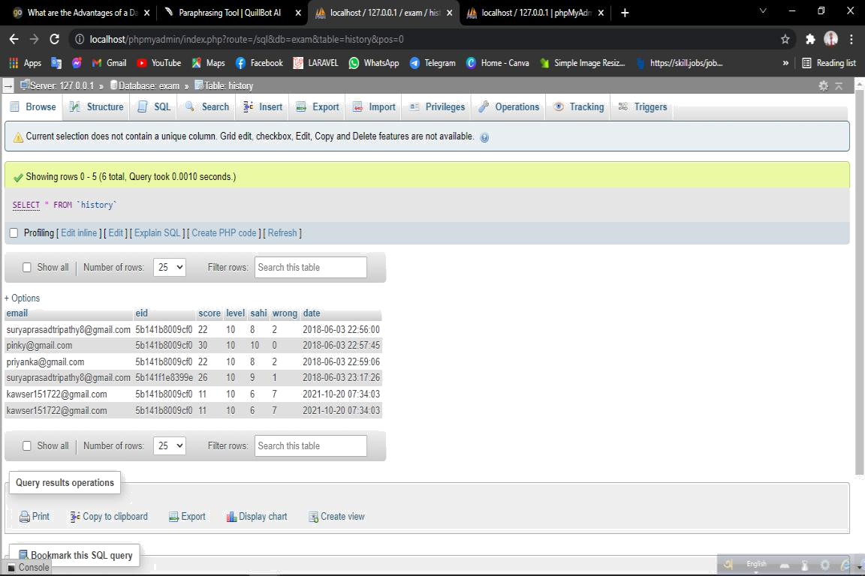

5.4 Figure User database

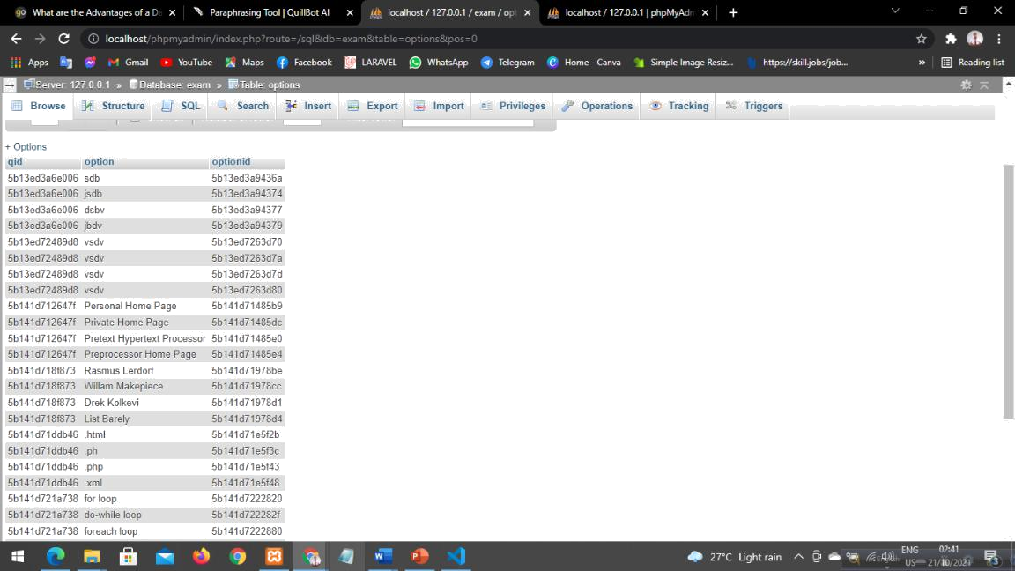

5.5 :Figure Question database

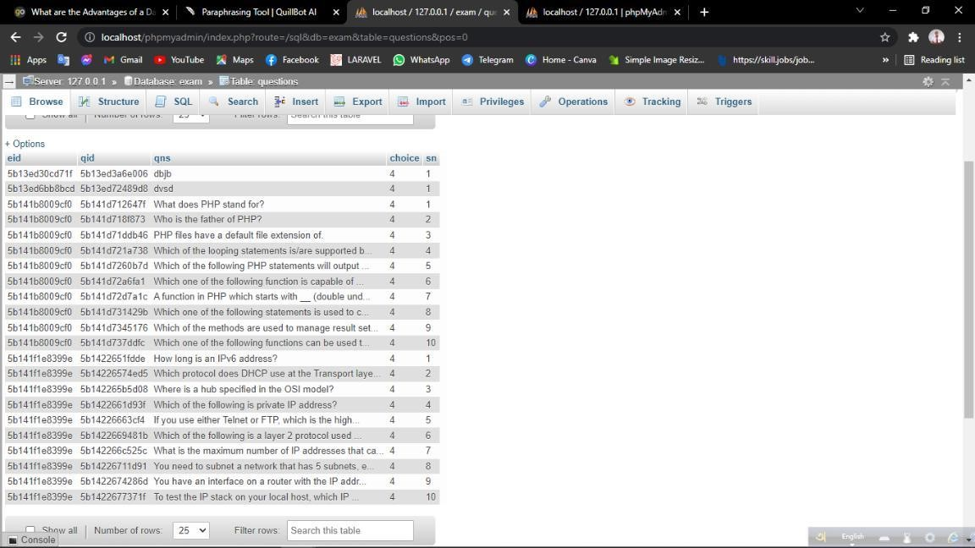

5.6 Figure : Answer database

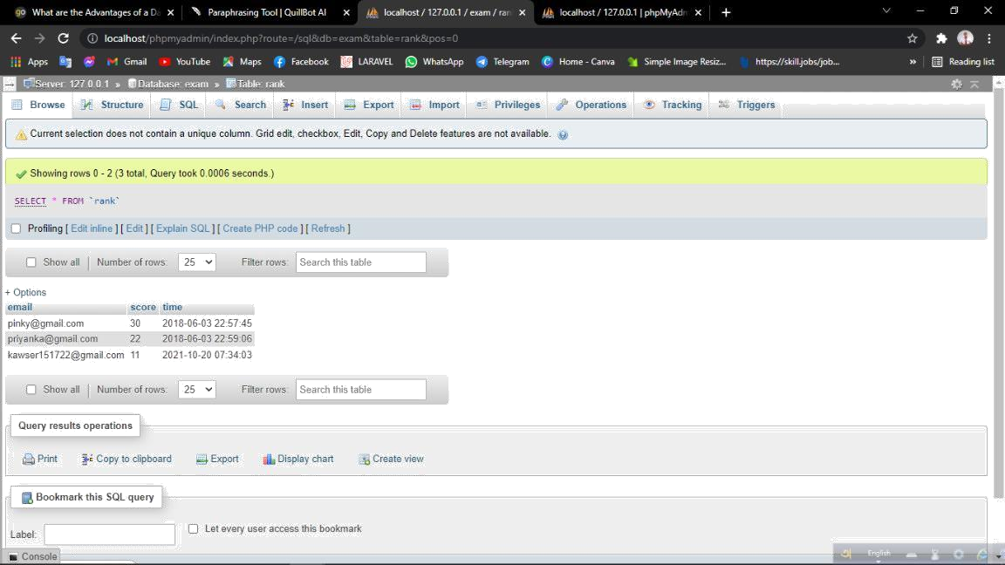

5.7 Figure : mark database

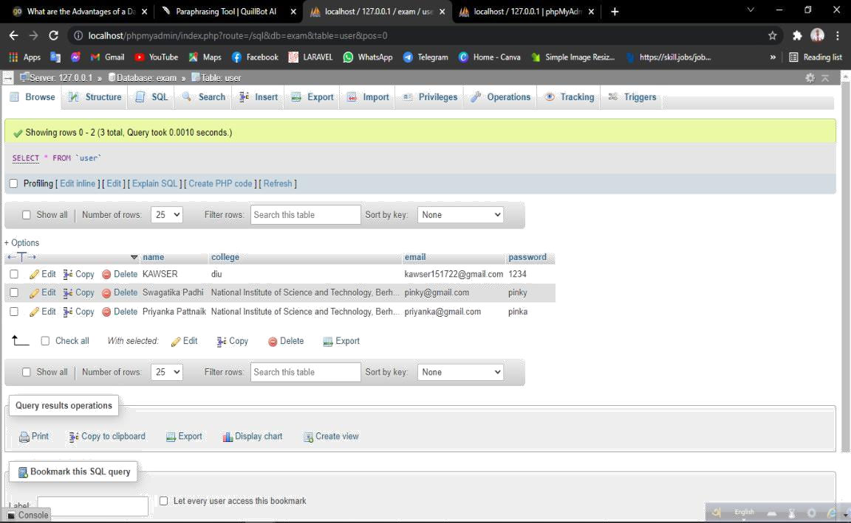

5.8 Figure : user database

## 5.2 Testing

Testing is the important part of agile model. All software certified by testing and analyzing. without test case no one is permitted to use.

|  |  |
| --- | --- |
| **Test Case-01** | **Responsive screen** |
| Test input | Large,small,medium. |
| Expected outcome | Fit for all kind of display |
| Actual output | Fully set for display |
| Result | passed |
| Tested on | 19-10-2021 |

|  |  |
| --- | --- |
| **Test Case-02** | **Registration** |
| Test input | Without registration |
| Expected outcome | Not allow quiz |
| Actual output | Registration Now |
| Result | Passed |
| Tested on | 19-10-2021 |

|  |  |
| --- | --- |
| **Test Case-03** | **Invaild user** |
| Test input | Email and password |
| Expected outcome | Invalid user message |
| Actual output | Invalid user message |
| Result | passed |
| Tested on | 19-10-2021 |

|  |  |
| --- | --- |
| **Test Case-04** | **Admin data add** |
| Test input | Admin panel and added data |
| Expected outcome | Data added database |
| Actual output | Data added database |
| Result | Passed |
| Tested on | 19-10-2021 |

|  |  |
| --- | --- |
| **Test Case-05** | **Data remove** |
| Test input | Admin data remove |
| Expected outcome | Remove data |
| Actual output | Remove data |
| Result | passed |
| Tested on | 19-10-2021 |

## 5.3 Result

Based on the test report, it is said how successful the project has been. In the middle of this test, there is a note depending on the user's usage. Here are the results of the report based on different test cases of the project. And passed. So it can be said that the project is usable. From the above observation, it can be said that

1. the project is easy to use.
2. Maximum security complete website.
3. More informative sites in less time.
4. Customer demand site.
5. One of all the university's admissions preparations.

## 5.4 Output

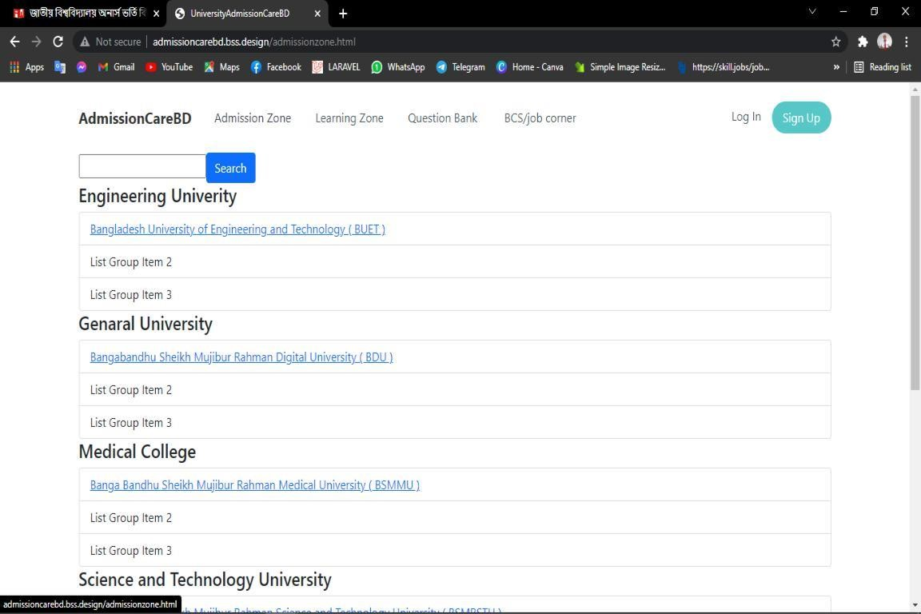

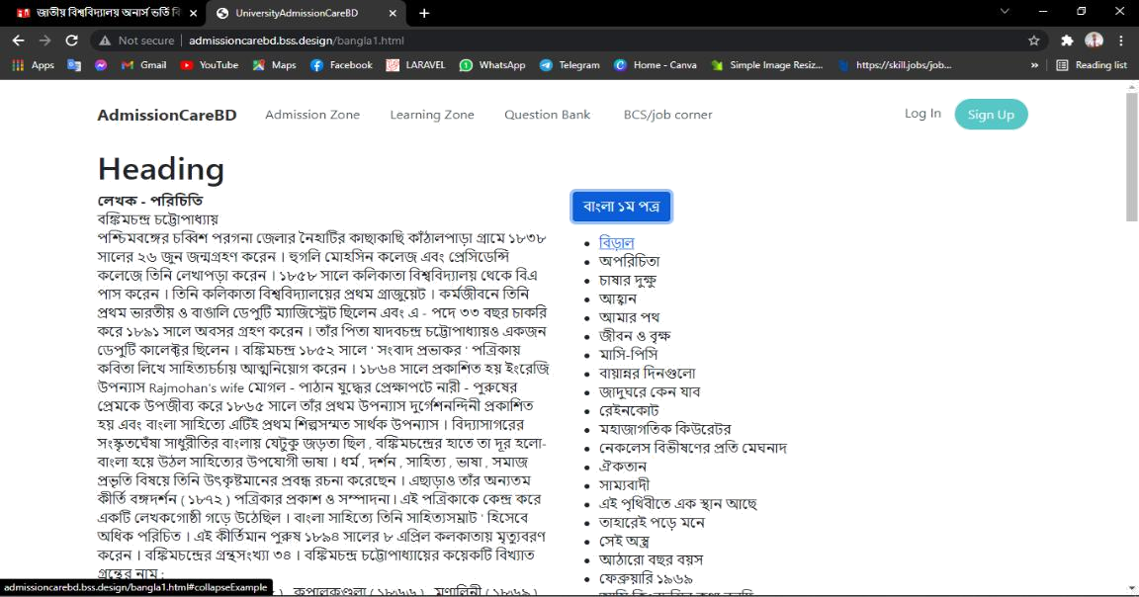

Figure: learning zone

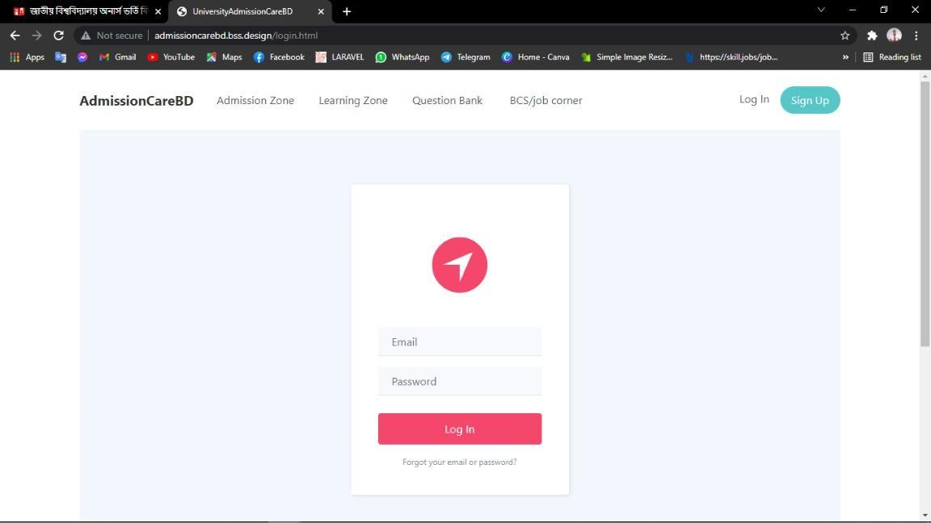

Figure : login

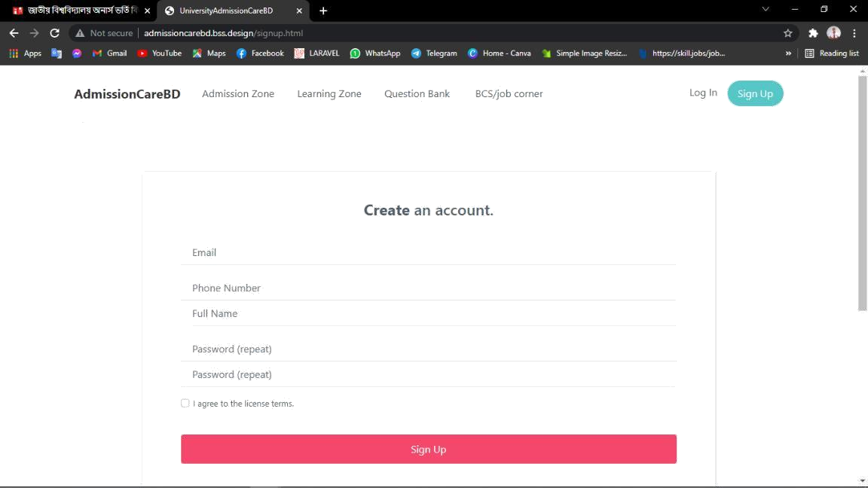

Figure: create account

# CHAPTER 6

**CONCLUSION & FUTURE SCOPE**

## 6.1 CONCLUSION & DISCUSSION:

We think we have been able to give a student from our project as much knowledge as they need to have for the admission test. And we are proud of our support for the future success of the students of the country. Also those who are involved in the admission test will benefit a lot through this project. We have to face many challenges while doing this project, due to hard work and perseverance, I have been able to implement the project properly

## 6.2 FUTURE SCOPE:

We want to add some more new features in the future, which will take our project further. Below are some of them:

1. Convert to Android app.
2. Use and download the system offline.
3. Job Study and BCS.
4. Added skills development courses and certificates.
5. Hospitality and transportation arrangements for students.

# References

1. Shahinoor, S. A., Ahmed, M., Akhter, R., & Tasnim, M. (2018). Admission Helpdesk.

1. Nath, N. R., Ahmed, M., & Rajbongshi, U. (2019). Private University Admission Assistant by Neel Ratan Nath.

1. Samad, M. A. Comparison of Preference and Admission Status of Applicants in Different Under-graduate Programs with Special Emphasis to DVM Degree at Bangladesh Agricultural University.

1. <https://www.admissionwar.com/>

1. <http://resultinbd.net/>

1. <http://www.eduicon.com/>

1. <https://www.w3schools.com/html/>

1. <https://www.w3schools.com/css/>

1. <https://www.w3schools.com/bootstrap/>

1. [https://searchsoftwarequality.techtarget.com/definition/agile-softwaredevelopment](https://searchsoftwarequality.techtarget.com/definition/agile-software-development)

1. [https://targetjobs.co.uk/careers-advice/job-descriptions/maintenanceengineer-job-description](https://targetjobs.co.uk/careers-advice/job-descriptions/maintenance-engineer-job-description)

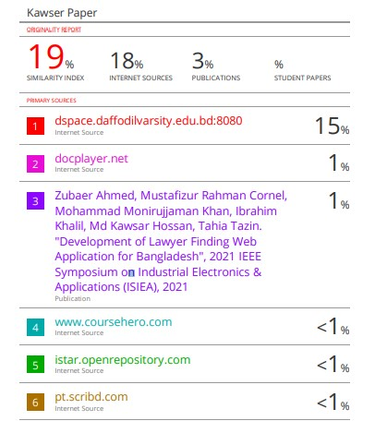



©Daffodil International University 35